FREQUENCIES VARIABLES=income
/FORMAT=NOTABLE
/STATISTICS=STDDEV MINIMUM MAXIMUM MEAN MEDIAN
/ORDER=ANALYSIS.

Frequencies

Notes
Output Created |  | 24-OCT-2022 21:19:29
Comments
Input | Data | C:\Users\GEORGE\Desktop\Stat Consulting\demo.sav
Input | Active Dataset | DataSet1
Input | Filter | <none>
Input | Weight | <none>
Input | Split File | <none>
Input | N of Rows in Working Data File | 6400
Missing Value Handling | Definition of Missing | User-defined missing values are treated as missing.
Missing Value Handling | Cases Used | Statistics are based on all cases with valid data.
Syntax |  | FREQUENCIES VARIABLES=income  /FORMAT=NOTABLE  /STATISTICS=STDDEV MINIMUM MAXIMUM MEAN MEDIAN  /ORDER=ANALYSIS.
Resources | Processor Time | 00:00:00.02
Resources | Elapsed Time | 00:00:00.02

[DataSet1] C:\Users\GEORGE\Desktop\Stat Consulting\demo.sav

Statistics
Household income in thousands
N | Valid | 6400
N | Missing | 0
Mean |  | 69.4748
Median |  | 45.0000
Std. Deviation |  | 78.71856
Minimum |  | 9.00
Maximum |  | 1116.00

FREQUENCIES VARIABLES=income
/FORMAT=NOTABLE
/STATISTICS=STDDEV MINIMUM MAXIMUM MEAN MEDIAN
/HISTOGRAM NORMAL
/ORDER=ANALYSIS.

Frequencies

Notes
Output Created |  | 24-OCT-2022 21:25:33
Comments
Input | Data | C:\Users\GEORGE\Desktop\Stat Consulting\demo.sav
Input | Active Dataset | DataSet1
Input | Filter | <none>
Input | Weight | <none>
Input | Split File | <none>
Input | N of Rows in Working Data File | 6400
Missing Value Handling | Definition of Missing | User-defined missing values are treated as missing.
Missing Value Handling | Cases Used | Statistics are based on all cases with valid data.
Syntax |  | FREQUENCIES VARIABLES=income  /FORMAT=NOTABLE  /STATISTICS=STDDEV MINIMUM MAXIMUM MEAN MEDIAN  /HISTOGRAM NORMAL  /ORDER=ANALYSIS.
Resources | Processor Time | 00:00:00.31
Resources | Elapsed Time | 00:00:00.36

[DataSet1] C:\Users\GEORGE\Desktop\Stat Consulting\demo.sav

Statistics
Household income in thousands
N | Valid | 6400
N | Missing | 0
Mean |  | 69.4748
Median |  | 45.0000
Std. Deviation |  | 78.71856
Minimum |  | 9.00
Maximum |  | 1116.00

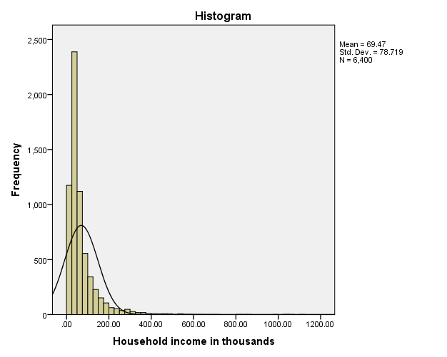

SUMMARY
The majority of cases are clustered at the lower end of the scale, with most falling below 100,000. There are, however, a few cases in the 500,000 range and beyond (too few to even be visible without modifying the histogram). These high values for only a few cases have a significant effect on the mean but little or no effect on the median, making the median a better indicator of central tendency in this example.

